G-14
THE MATHMASTER CHALLENGE SYSTEM
SOFTWARE DESIGN DOCUMENT
https://github.com/fkwitty8/MathMasterSystem
SUPERVISOR: Dr. Brian Muchake
Name | Registration Number | Student Number
Sabunyo Saul | 23/U/17172/PS | 2300717172
Ainembabazi Kiiza Davis | 22/U/22713 | 2200722713
Mugisa Joseph | 23/U/0810 | 2300700810
Mbasani Pauline Peace | 23/U/0765 | 2300700765
Kiyimba Fahad | 23/U/0628 | 2300700628

Contents
1. Introduction 5
1.1 Purpose 5
1.2 Scope 5
1.2.1Goals 5
1.2.2. Objectives 5
1.3 Document Overview 5
1.4 Reference material 7
1.5 Definitions and Acronyms 7
1.5.1 Definitions 7
1.5.2 Acronyms 9
2. System overview 10
2.1 System Description 10
2.2 Software requirements 11
2.3 Hardware requirements 11
3. System architecture 12
3.1 Architectural Design 12
3.2. Decomposition Description 13
3.3 Design Rationale 18
4. Data design 19
4.1 Data Description 19
4.2 Data Dictionary 22
5. Component design 24
6. Human interface design 28
6.1 Overview of the user 28
6.2 Screen images 29
6.3 Screen objects and actions 33

LIST OF FIGURES
Figure 3. 1 System Architecture 11
Figure 3. 2 A usecase diagram 12
Figure 3. 3 A sequence diagram 13
Figure 3. 4 An activity diagram for pupil registration 14
Figure 3. 5 An activity diagram for school representatives’ registration 15
Figure 3. 6 An Activity diagram for attempting challenge 16

Figure 4. 1 EER diagram 21

Figure 6. 1 Screen image for attempting challenge 29
Figure 6. 2 Screen image for log in of a pupil. 30
Figure 6. 3 Screen image for log in of a school representative 31
Figure 6. 4 Screen image for uploading schools 32
Figure 6. 5 A graph 32
Figure 6. 6 A trophy image 33

LIST OF TABLES
Table 1. 1 Document Overview 6
Table 1. 2 Definitions 7
Table 1. 3 Acronyms 9

Table 4. 1 Data Table 19
Table 4. 2 Data Dictionary 22

Table 5. 1 Pupils’ Registration 24
Table 5. 2 Representative Verification 25
Table 5. 3 Take-up Challenge 26

1. Introduction

1.1 Purpose
This MathMaster Challenge Software Design Document is the detailed plan which ensures that all stakeholders involved have a clear understanding of the goals, requirements and functionality of the system. This document facilitates effective communication, collaboration and progress tracking throughout the system development lifecycle. It outlines the system architecture and design, implementation details and change management during implementation. It also describes data and component design of the MathMaster Challenge system.

1.2 Scope
The system will enhance the mathematics challenge, enabling pupils from registered schools to participate where the best two pupils will be recognized on the website. It will also provide statistical analysis of the entire challenge. Pupils from registered schools, registered school representatives and a registered system administrator will access and use the system in various ways like validating pupils, attempting the challenge and a lot more.

1.2.1Goals
- To promote application of mathematical concepts to solve real-world problem
- To enhance academic performance of students in mathematics
- To foster critical thinking and logical reasoning abilities among students

1.2.2. Objectives
- To design the system that will enable the pupils take part in the Math challenge
- To implement the system so as to come out with feasible system that can be used by the users to their interest.
- To test the system in order to ensure that it meets the functional and non-functional requirements with little or no errors

1.3 Document Overview
This SDD has been arranged in chapters that show the requirements of the pupil’s mathematics challenge system.

Table 1. 1 Document Overview
Table 1.1 summarizes the document overview
CHAPTER | DESCRIPTION
1.INTRODUCTION | It basically identifies the purpose and scope of the MathMaster Challenge system Design Document.
2.SYSTEM OVERVIEW | It states a general description of the functionality, context and design of the system.
3.SYSTEM ARCHITECTURE  3.1 Architectural Design  3.2 Decomposition Description  3.3 Design Rationale | It is divided into three sub-levels.  This shows the arrangement of the system in terms of modules and the relationships between the modules.  This provides a breakdown of the subsystems in the architectural design.  This provides the rationale for selecting the architecture described including all critical issues and trade/offs that were considered.
4. DATA DESIGN  4.1 Data Description  4.2 Data Dictionary | This is also split into sublevels.  This explains how the information domain of the system is transformed into data structures.  This provides a list of the system entities along with their types and descriptions
5. COMPONENT DESIGN | This provides a more detailed view of the systematic operation of each component.
6.HUMAN INTERFACE DESIGN  6.1 Overview of the user  6.2 Screen images  6.3 Screen Objects and Actions | This has been broken down into sub-levels  It is basically describing the system from the user’s perspective.  This displays snapshots showing the interface from the user’s perspective.  These provide a visual representation of the system’s functionality, allowing the users to interact with elements on the screen.

1.4 Reference material
- A. Dennis, B.H.Wixom, R.M.Roth. System Analysis and Design 5th edition. John Wiley & Sons, Inc. 2012, 2009.
- IEEE Standard 1016-1998, IEEE Recommended Practice for Software Requirements Specifications, IEEE Computer Society, 1998.

1.5 Definitions and Acronyms

1.5.1 Definitions
Table 1. 2 Definitions
Table 1.2 shows the definitions used in this document

TERM | DEFINITION
- Activity diagram | This is a graphical representation of workflows of activities and actions with support for choice, iteration and concurrency.
- Class diagram | This is a static diagram that depicts the structure of a system by showing the classes, their attributes and relationships.
- DBMS | A system that allows creation, management and controls of database.
- Feedback | This refers to the output of the system for example emails sent.
- Leaderboard | This is a dashboard that displays the ranking of participants based on their scores.
- MySQL | A DBMS that allows database creation, management, control and provides security to the database created
- RDBMS | A database system that organizes data in the database in form of relations or tables with rows/records/tuples and columns/fields.
- Use case diagram | This a graphical depiction of a user’s possible interactions with a system.

1.5.2 Acronyms
Table 1. 3 Acronyms
Table 1.3 shows the acronyms used in this document
ACRONYM | MEANING
- CLI | Command Line Interface
- DBMS | Database Management System
- EER | Enhanced Entity Relationship model.
- GUI | Graphical User Interface
- IEEE | Institute of Electrical and Electronics Engineers
- MySQL | My Structure Query Language
- RDBMS | relational Database Management System
- SDD | Software Design Document

2. System overview

2.1 System Description
An international body intends to organize a mathematics challenge where only pupils from registered schools are to participate, best two winners are to be recognized and the overall performance statistics of pupils and schools are to be provided. This problem is to be solved through the development of the system described below.
Math Master Challenge system requires all participating schools to be registered in the system proceeded by the registration of pupils from registered schools willing to take up the challenges. Participating pupils will register using a command line interface and they are provided with the menu on the interface to enhance the registration. The registered pupil is permitted to view challenges that are still valid and in case of more than one valid challenge the pupil is allowed to choose which one they would like to participate in and they are allowed to participate in more than one challenge if they wish. A particular pupil can be rejected if their school registration number does not match registered School numbers, the pupil is informed instantly on the command line interface. In case everything is okay the pupil is accepted, their record added to a file and an email notification is sent to the respective School representative to confirm the applicant.
A well validated and registered school representative also uses the command line interface to log into the system in order to view Applicants, confirm or reject applicants and this is aided by a menu that displays all new applicants with their registration number. If one is rejected their data is deleted from the file and put in the database table rejected and the accepted ones are also deleted from the file and moved to the database table accepted. For all cases an email address is sent, any pupil who tries to register again under the same school after being rejected is denied access and informed on the command line interface.
A registered administrator uploads the schools into the system indicating the name, district, school registration number, email and name of the school presentative who are first validated and then registered into the system. The administrator uploads questions into the web system. Incase 10 questions are to be attempted by the students, the administrator uploads 100 questions such that each pupil attempts 10 randomly selected questions. He / She also sets parameters including date of opening and closing, time allowed for each challenge and how many questions will be attempted by each participant.
As long as the date is still valid the participant can log in and attempt the challenge at any time. Each question is presented one after another on the click of next. Each time a question is presented the time and number of questions remaining shall be displayed on top of that question. In case a student submits a wrong answer three marks are deducted, not sure no deduction of Marks and no addition, correct answer the participants is given the marks assigned to the question. Once the time for attempting expires the participants challenge is closed and the participant is given their score and a report which includes scores and time taken for each attempted question and the total time, they have taken to complete the challenge.

2.2 Software requirements
- Web browser
- Apache webserver
- Java compiler
- Database Management System Software (DBMS)

2.3 Hardware requirements
- Database servers
- Desktop computers
- Phones/Tablets

3. System architecture

3.1 Architectural Design
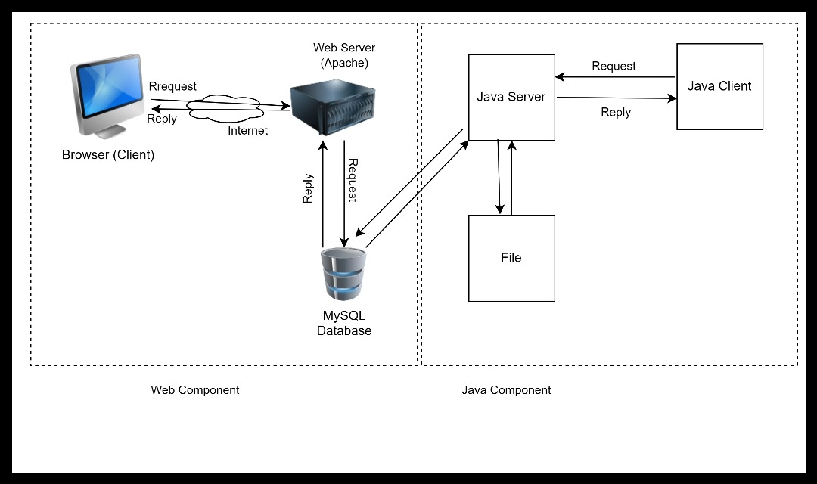
Figure 3. 1 System Architecture
Figure 3.1 illustrates the high-level architecture of MathMaster Challenge System
Presentation Layer: The web browser acts as the presentation layer, displaying the user interface elements to users. The user interface provides a both graphical interface and a command line interface for administrators, School Representatives and students to interact with the system in registration, log in and taking up challenges etc.
Application Logic Layer: The application logic resides on the web server, handling user interactions, data processing, and communication with the database. It handles user validation and verification, evaluation of challenge submissions, plus ranking calculations
Data Layer: The database server stores all MCMS data (Administrator, challenge, school representative, students/ participants, submissions leaderboard and feedback etc.) using a relational database management system (RDBMS) like MySQL.
Text File: It temporarily stores registration details awaiting for approval.
Internet: It provides connectivity between the client-side and the server-side.

3.2. Decomposition Description
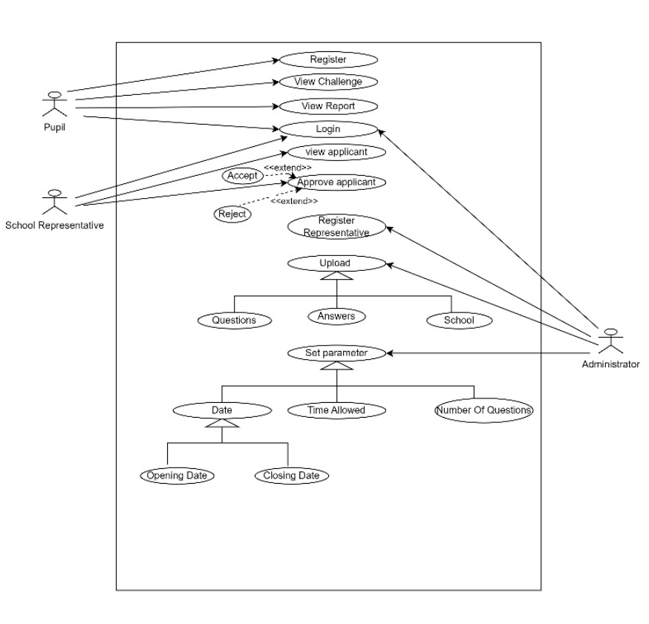
Figure 3. 2 A use case diagram
Figure 3.2 shows the interactions between the actors/users and the system

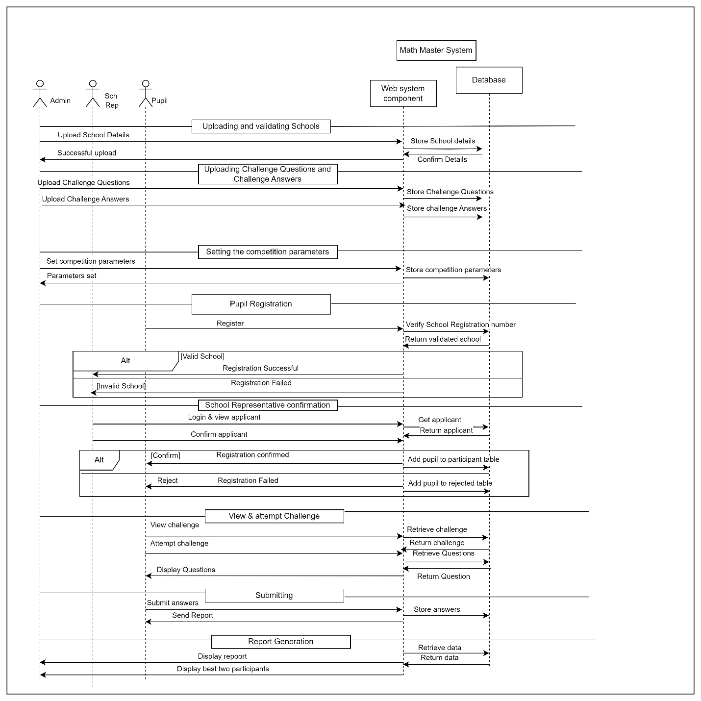
Figure 3. 3 A sequence diagram
Figure 3.3 shows the dynamic behavior and interactions of a system.

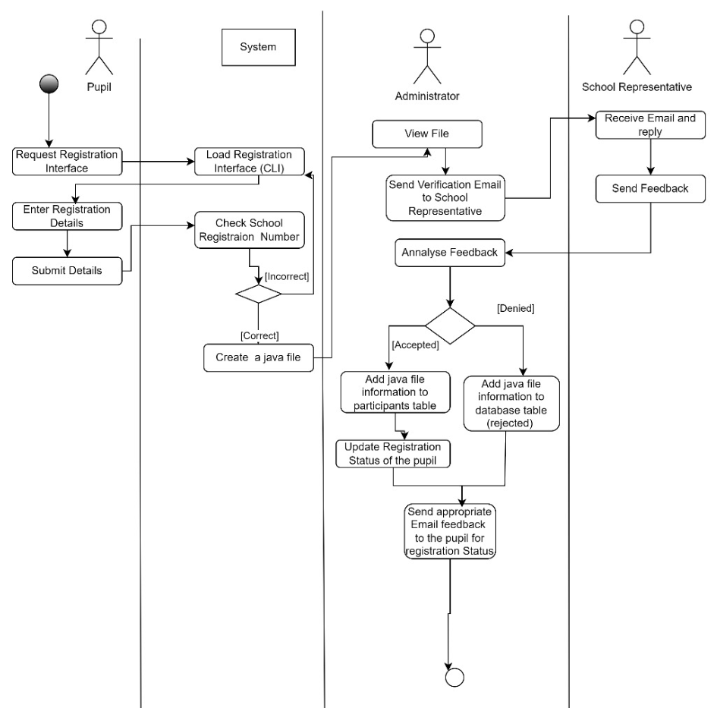
Figure 3. 4 An activity diagram for pupil registration
Figure 3.4 illustrates the action of pupil registration
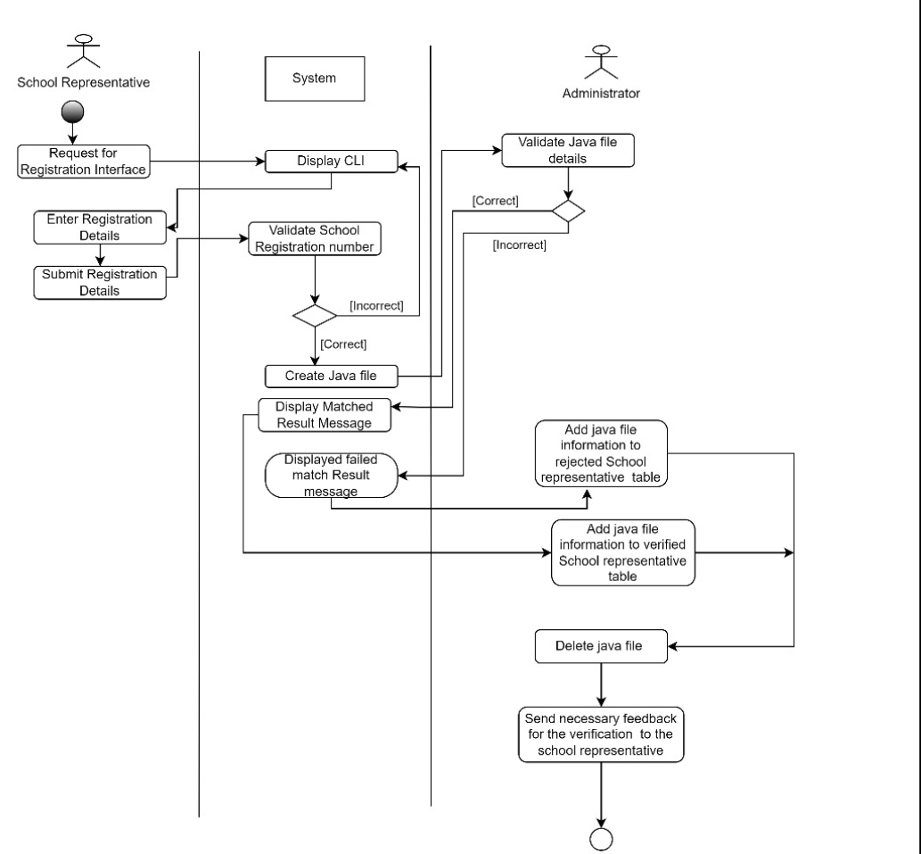
Figure 3. 5 An activity diagram for school representatives’ registration
Figure 3.5 illustrates the action of school representatives’ registration
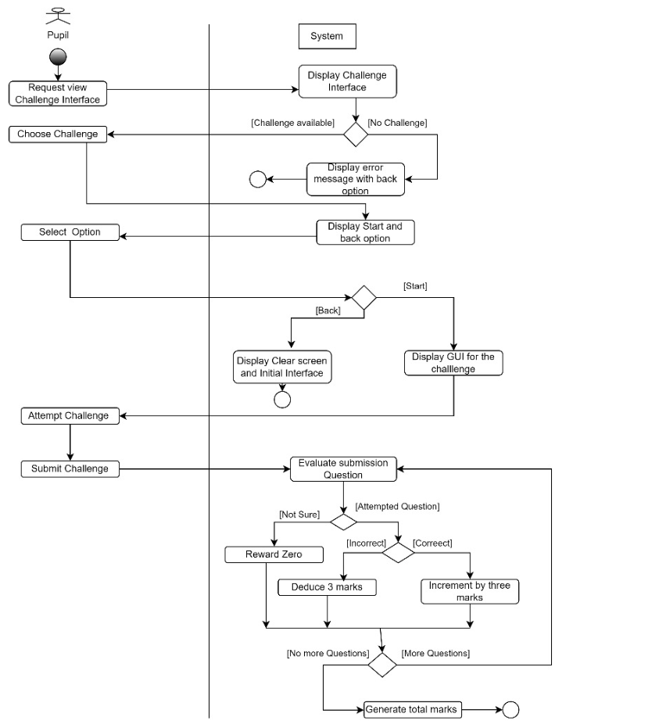
Figure 3. 6 An Activity diagram for attempting challenge
Figure 3.2.5 illustrates the action of attempting challenge by the pupil

3.3 Design Rationale
We selected the above architecture because it enhances the fulfillment of functional and non-functional requirements of each user. It also facilitates good user experience through intuitive web interface complemented by the command line interface which makes it easy to master and use commands.
Efficient and secure data storage and management facilitated by the database which interacts with the server to store and supply any necessary data. The architecture facilitates high system performance since it involves temporary data storage on file for easy and quick access, reducing the rate at which the database is queried for data hence high performance.

4. Data design

4.1 Data Description
Table 4. 1 Data Table
Table 4.1 shows the data used in the system
Entity | Attributes
Pupil | PupilID  FirstName  LastName  UserName  Email  Date_of_birth  SchoolRegNo  Password
School | Name  SchoolRegNo
School Representative | FirstName  LastName  UserName  Email  Password  RepID
Administrator | Name  Email  Password  AdminID
Challenge | Name  NumberofQuestions  TimeAllowed  OpeningDate  ClosingDate  ChallengeID
ChallengeSubmission | SubmissionID
Question | QuestionID  Qn
Answer | AnswerID  Ans

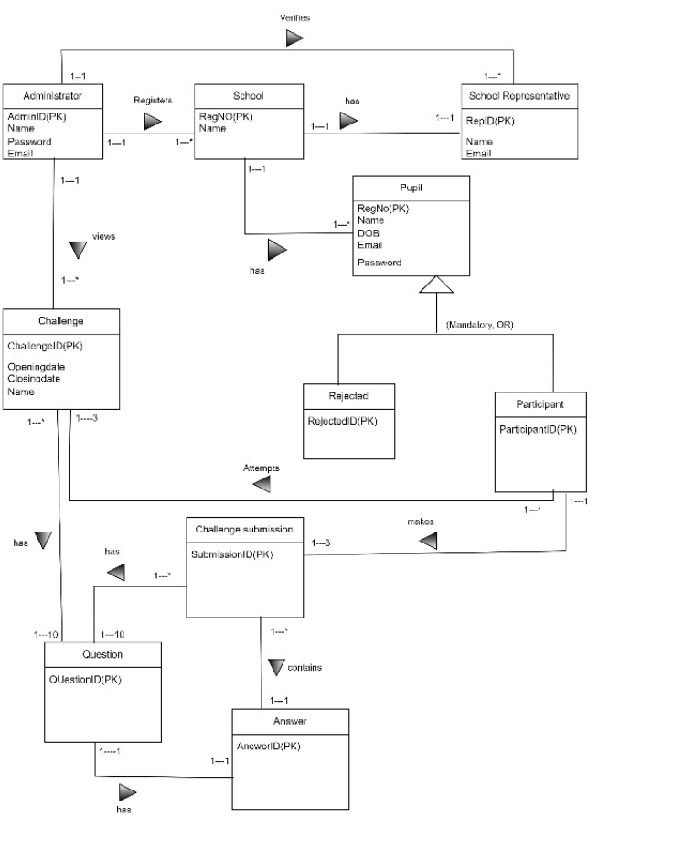
Figure 4. 1 EER diagram
Figure 4.1 shows an EER diagram generated from the data

4.2 Data Dictionary
Table 4. 2 Data Dictionary
Table 4.2 illustrates the entities involved and their additional information
Entity | Attribute | Datatype | Size | Key | Description
Pupil | FirstName | Varchar | 255 |  | First Names of a registered pupil
 | LastName | Varchar | 255 |  | Last Names of a registered pupil
 | UserName | Varchar | 255 |  | User Names of a registered pupil
 | Email | Varchar | 30 |  | Email of pupil to which info about their status can be sent
 | Date_of_birth | Date |  |  | Date at which a user was born
 | SchoolRegNumber | Varchar | 5 |  | Registration number of the school of the pupil
 | PupilID | Varchar | 10 | primary key | A unique identifier of the pupil
 | SchoolRegNo | Varchar | 10 | Foreign key | It references the school
 | ChallengeID | varchar | 10 | Foreign key | It references the challenge
School | Name | Varchar | 35 |  | Name of a registered school
 | RegistrationNumber | Varchar | 5 | primary key | Registration number of the school with the ministry
 | RepID | Varchar | 5 | foreign key | It references the school representative
School Representative | FirstName | Varchar | 255 |  | First Name of the school representative
 | LastName | Varchar | 255 |  | Last Name of the school representative
 | UserName | Varchar | 255 |  | User Name of the school representative
 | Email | Varchar | 30 |  | Email Address of the school representative for notification sending
 | Rep ID | Varchar | 15 | primary key | Uniquely identifies each school representative
Administrator | Name | Varchar | 15 |  | Name of the administrator
 | Email | Varchar | 30 |  | Email address of the administrator
 | Password | varchar | 25 |  | Password used for logging in
Challenge | Name | Varchar | 15 |  | Name of a particular challenge
 | No of Questions | Integer | 2 |  | Number of questions to be attempted
 | OpeningDate | Date |  |  | Date on which the challenge will commence
 | ClosingDate | Date |  |  | Date on which the challenge will be closed
 | TimeAllowed | Time |  |  | Total time allowed for one to attempt challenge
 | ChallengeID | Varchar | 5 | primary key | A unique identifier of each challenge
ChallengeSubmission | SubmissionID | varchar | 10 | Primary key | A unique identifier of each submission
 | ChallengeID | varchar | 10 | Foreign key | Reference a particular challenge
 | PupilID | varchar | 10 | Foreign key | References a participating pupil

5. Component design
Table 5. 1 Pupils’ Registration
Table 5.1 shows the component used by pupils for registration
Main success | PARTICIPANT | SYSTEM | ADMINISTRATOR | SCHOOL REPRESENTATIVE
 | 1).Requests registration interface  3). Enter registration details  4). Submit details | 2). Loads the command line with clear prompts  5). Validates school registration number  6). Creates a Java file of registration details  7). Sends verification email to the school representative | 9). Receives and analyzes the feedback from the school representative  10). Copy Java file information to the database and delete the Java file  11). Send email to participants for successful registration | 8). Replies to the email and sends feedback
ALTERNATIVE FLOW | 6). If the school registration number is incorrect, an error message appears on the screen and prompts the user to renter the registration details (only three times are allowed).  10). If it’s a deny feedback, the administrator copies the information from the Java file to a database table rejected,`

Table 5. 2 Representative Verification
Table 5.2 shows the school representatives’ verification process
MAIN SUCCESS | SCHOOL REPRESENTATIVE | SYSTEM | ADMINISTRATOR
 | 1.Requests for registration interface  3.Enter  registration details  4. Submit Registration details | 2. Displays the Command Line  5. Validate school representatives’ details  6.Create Java file  8.Display “Matched Results” message | 7.Check/ validate Java file information/data  9. Add Java file information to verified school representative table  10. Delete Java file  11. Send “Successful verification” message to the school representative
ALTERNATIVE FLOW | 6. If the records don’t match, Display “failed match” message. The administrator copies information from the file and adds to the rejected school representatives’’ table. He then sends “failed verification”

Table 5. 3 Take-up Challenge
Table 5.3 shows the component where a pupil takes up a challenge
Main success | Pupil | System
 | 1.Requests the view challenge interface  3. (For one or more challenges available) chooses a challenge.  5.selects one option  8. Attempt Qn.  9. Submit questions | 2.check for available challenges and displays challenge interface  4. Displays “start challenge” and” back” option for the pupil.  6. checks Option  7. (For start option selected) display Qn interface.  10. Check and Evaluate each submitted question  11.(for answered Qn) checks whether correct or not  12.(for correct Qn) award three marks  13. check whether more questions available  14.(No more questions) Generate total marks
Alternative flow | 3. if no challenges available, display error message and back option  7. If back option is selected, the system clears screen and displays initial interface.  11.(For unanswered Qn/ not sure) reward marks  12.(For incorrect Qn) deduct three marks from the total  13.(If more Questions) iterate through until all are done to be awarded

6. Human interface design

6.1 Overview of the user
Pupil Interaction
A pupil will always start from the command line interface with the command (MathMaster challenge). A menu will be provided to assist their interaction for example 1. Login 2.Register
On the command of (1) the pupil will be provided with an interface for them to enter their details and on the command of (2) the pupil will be provided with a registration interface.
The command viewChallenge will display all the available challenges and a user will use command select challenge to choose the challenge they are going to attempt. Command attempt challenge will direct to a web interface where the challenge will be attempted.
The Web interface will display one question at a time with a space for solution. A button [next] will be used to submit answer for current question and request for another question.
Representative interaction
The representative will use a similar login criterion, the command viewApplicants will be used to display all applicants and a command No applicantName will reject applicant and yes applicantName will accept applicants.
Administrator interaction
The administrator uses same login procedure and the command uploadQuestions, uploadSchools are what the administrator uses to interact with the system and the view report will be used to access the reports of the challenge.

6.2 Screen images
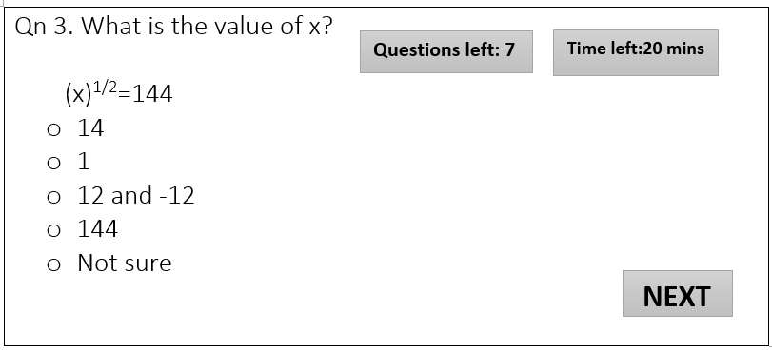
Figure 6. 1 Screen image for attempting challenge
Figure 6.1 illustrates the interface the pupil interacts with while attempting a question
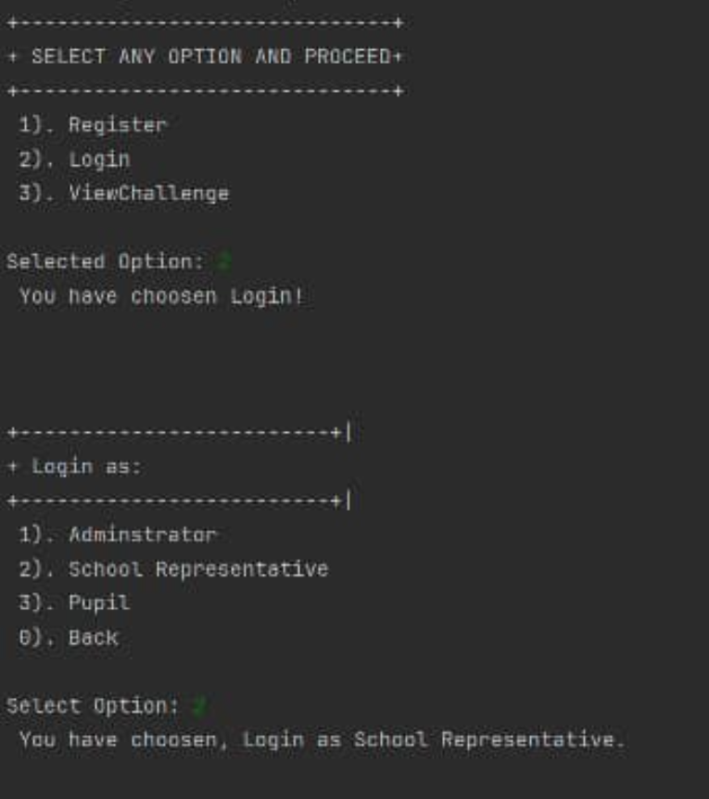
Figure 6. 2 Screen image for log in of a pupil.
Figure 6.2 illustrates the command line interface a pupil interacts with when logging in
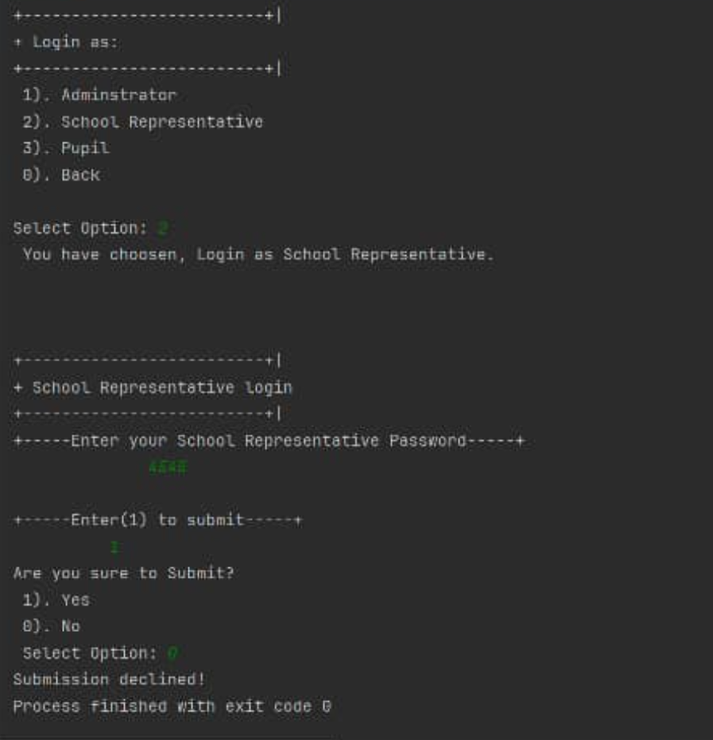
Figure 6. 3 Screen image for log in of a school representative
Figure 6.3 illustrates the command line interface for school representatives’ log in

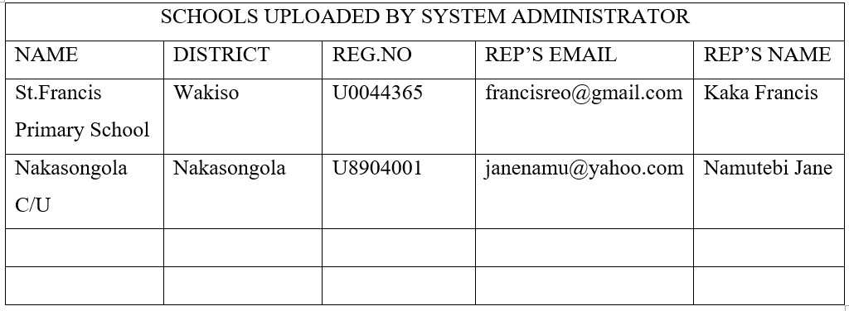
Figure 6. 4 Screen image for uploading schools
Figure 6.4 shows the table used to upload schools by an administrator

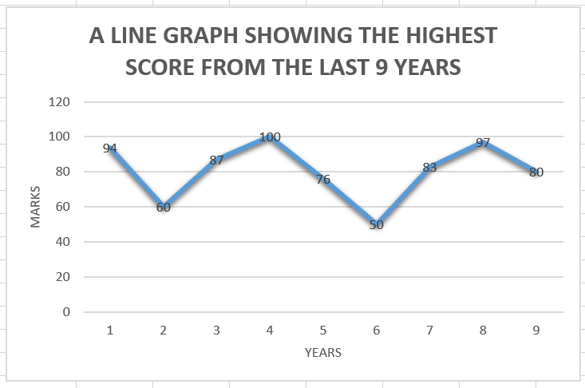
Figure 6. 5 A graph
Figure 6.5 illustrates the graph showing the highest score for the last 9 years

6.3 Screen objects and actions
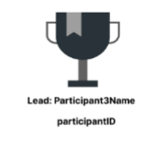
Figure 6. 6 A trophy image
Figure 6.6 shows the leading participants’ details and is constantly updated depending on the point rankings

